**DIGITAL MARKETING PROJECTS LIST (TOTAL-5)**

1. **Create a Meta Ads audience for an Ed tech company for the Digital Marketing Course**.

**Context and expected submission:**

You need to create a Meta Ads Audience for digital marketing course of an Ed tech company, by identifying suitable locations, age language, demographics, interest and behavior.

List all the criteria along with your findings and also mention the reasons for your choice.

**Outcome:** You will be able to create an effective and optimized audience for your Meta Ads, which will give you better return on investment.

**--------------------------------------------------------------------------------------------------------------**

**Ans) Targeting the right audience done using factors like:**

Suitable locations - Located in United States with branches all over.

Demographics:

Age – 18+ onwards though there is no max limit to learn new skills.

Gender – Both male/ females are benefitted from this course.

Language – English

Interest and behavior – Ed tech companies have a huge market share due to wide usage of online learning sites these days post Covid. It provides an engaging learning experience and interactive sessions unlike the traditional methods of learning.

Digital marketing is powerful as it directly relates to customers’ needs globally.

Audience – Business owners and Entrepreneurs who wants to start business and promote their services in the market. Marketing professionals/ IT staff /Sales representatives all benefits from digital marketing course.

Educators (teachers and professors who use educational technology in their classrooms), teachers and parents. KG to grade 12 students for interactive sessions, college and university students, providing study aids and tools to support learning journeys providing an engaging learning experience.

Students now have the power to access world-class higher education from anywhere.

**Reasons of choice** selecting these criteria is to target the right audience and get maximum customers towards my product/ service creating brand awareness.

Focus on Quality and not Quantity.

Have university partners and collaborations with university support services.

It has a perfect blend of data with insights.

1. **Formulate a Social Media strategy for a new product launch.**

**Context and Expected Submission:**

You are in an electronics company and your company is planning to launch a new product in the market which is a smart watch.

You can assume its unique features, and need to identify in which social platforms you will post about it.

Mention the products unique features chosen media platforms and the strategies which will include captions, creative lines and themes.

**Outcome:** You will be able to formulate implement and execute an effective social media campaign, for a new product/service, you want to launch in the market, which increase awareness for your product or service.

**Ans) Unique features of the Smart Watch:**

* Android smart watch with mental health tools
* Fitness tracker
* In built GPS
* Water-proof
* Impressive circular AMOLED display
* Comprehensive health tracking
* Sleek design
* Accurate workout monitoring
* Best smartphone integrations
* Notifications and Alarm systems

**Chosen social media platforms include:**

* Facebook
* Instagram

**Strategies:**

Captions: Stay sharp and stay classy.

Creative lines: One touch, one call / Innovate something new/ Quality at best price.

Themes:

1. **Do competition analysis for enhancing your payment Gateway.**

**Context and Expected Submission:**

You own a payment gateway which is new in the market. Analyze at least 5 popular payment gateways. Find out their strengths and weaknesses and what changes you can incorporate in the payment gateways to make it better. Mention the entire analysis and list the changes.

**Outcome:**

You will be able to perform in depth competition analysis so that you can identify the pros and cons of your own strategy and enhance it to get more returns.

Ans) 5 popular payment Gateways might include:

* Amazon
* Apple Pay
* Payoneer
* Pay Pal
* Google Pay
* Secure Pay

**Strengths and Weaknesses: Payment Gateways**

|  |  |
| --- | --- |
| Strength | Weaknesses |
| Easily integrated into websites/ online stores | Can be expensive with additional charges |
| Offers secure and user friendly payment procedures | Merchants might need to organize their own PCI compliances. |
| Variety options available like payment cards and e-wallets | Compatibility issues possible |
| Fraud detection tools available | Customer support is limited to emails rather than phones or live chats. |
| Customized branding helps in brand awareness |  |

**Mention the complete analysis and list the changes:**

1. By providing widest range of payment methods
2. Avoid creating site account for visitors before payment
3. Avoid redirects during the payment processing.
4. Keeping payment information as secure as possible
5. Keeping information requests minimal duet to sensitivity.
6. **Create a content marketing strategy for a FMCG Company.**

**Content and Expected Submission:**

You are a marketing head in a fast moving consumer goods company (FMCG). The product profile of your company is almost similar to ITC. You need to create a content marketing strategy where you promote your products using text, image and video form of contents.

List minimum 5 points where you need to mention the type of content, the theme/strategy and how it will make an impact when the audience consumes it.

**Outcome:**

You will be able to formulate, implement and execute marketing content strategy which circulates the content around the internet, in an influencing way convincing you and the viewers to remember your brand.

Ans)

**Content marketing strategy:**

Being head of FMCG Company, my content marketing strategies would include posting blogs, videos, infographics and other educational and engaging content for consumers. By providing valuable content, I can build trust, and credibility with my audience, drive sales and increase my rankings in the search engines.

Being similar to the product profile of ITC some of the products would include:

ITC has a better ranking in FMCG due to stable outlook of cigarette (tobacco) volume growth as its primary business. FMCG deals with home and personal care products, packaging and disposable item materials.

**Promoting products using text, image and video: Hindustan lever (HUL) (FMCG)**

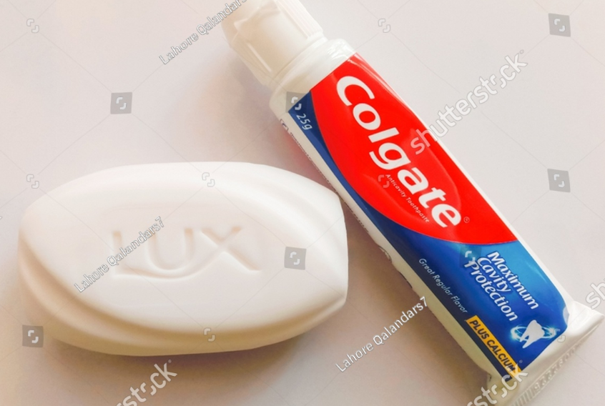 

**5 Points where mention needed for content type, theme/strategy:**

* Set the mission and goals
* Establish your key performance indicators
* Know your audience
* Figure out the best content channels
* Decide on content types
* Identify and allocate resources
* Create a content calendar, create content, distribute and market, measure results.
* Include blog posts, emails, newsletters, social media posts, pod casts e-books, videos.

Themes include – If content is informative or educative to people, whether visually appealing or not, if it includes product recommendations, economically related, engage audience with quiz or surveys or curiosity and periodic feedbacks etc. Leveraging data insights to guide efforts and distribution is required.

**Good content strategy helps to:**

* Build audience trust
* Improve brand awareness
* Boost SEO efforts
* Generate Leads

**An effective content strategy includes 5 elements namely**

* Audience personas
* Brand Story
* Content marketing mission
* Business case
* An action plan

**How the content will make an impact on the audience and convince them with brand image?**

Consistent high quality engaging content impacts audience decision making ability positively. Healthy brand image helps business success in future. Good content helps to create emotional connect with consumers. It can resonate with target audience emotionally. This helps foster stronger bonds between consumers and brands. Content is an effective way to reach prospective buyers and drive revenue as consumers make informed buying decisions.

1. **Design a structure for an E-commerce website which ensures easy crawlability.**

**Content and Expected submission:**

You need to design the website structure of an E-commerce website which has listed at least 15 products divided into 3 categories. Structure and linking should be in such a way that the crawler should be able to navigate the entire website. Make a flow chart for the entire structure of the website.

**Outcome:**

You will be able to develop a website design which is easy in navigation by crawlers so that it can be effortlessly crawled and indexed by search engines.

Ans)

**CATEGORY 3**

**CATEGORY 2**

**CATEGORY 1**

**NAME OF E-COMMERCE WEBSITE**

‘‘